**React**

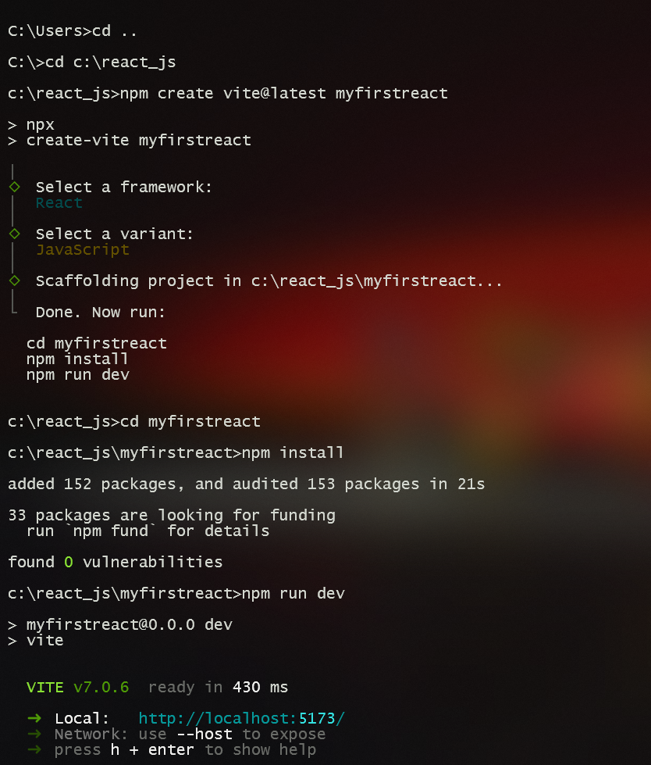

### ***App.jsx:***

| function App() {  return(  <h1>  Welcome to the first session of React  </h1>  ); }  export default App; |
| --- |

### ***Output ScreenShots:***

### 